**CHAPTER 4**

RESULTS

# Presentation of automation results.

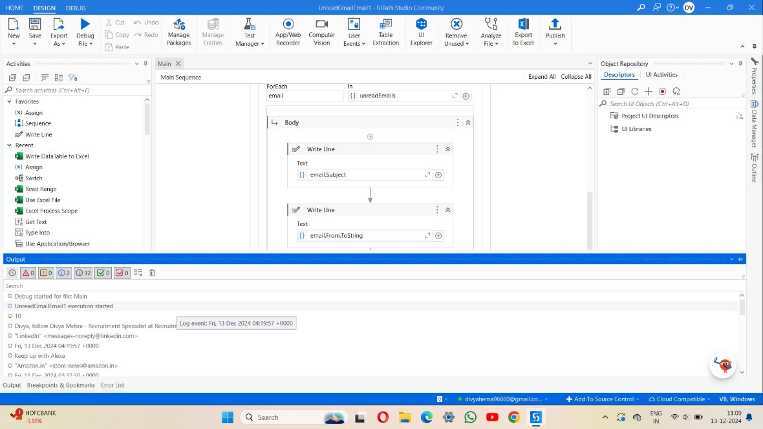

## Fig 4.1 Showing the number of unread emails

As shown in the fig 4.1 shows a notification badge representing the number of unread emails. This count is typically displayed as a bold number within a small, circular, and often red-highlighted icon. It signifies the presence of pending messages that have not been opened or read, usually appearing on the email app icon or within the inbox section to draw the user’s attention.

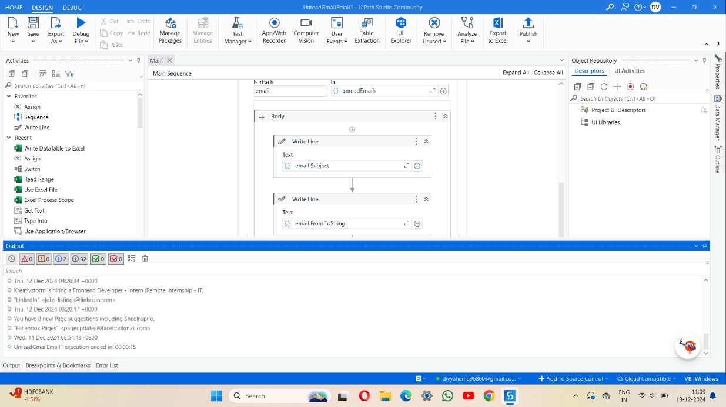

## Fig 4.2 Description of unread emails with date

Figure 4.2 illustrates the trend of unread emails over a specific period. The x-axis represents the dates, while the y-axis denotes the number of unread emails. The graph highlights fluctuations in the volume of unread emails, which may be attributed to variations in email frequency, user engagement, or work schedules.

* 1. **Metrics and Key Performance Indicators (KPIs) used for evaluation.** The performance of the automated mail counter system is evaluated through several key metrics and KPIs. These indicators provide insights into the system’s efficiency, accuracy, and cost-effectiveness. The following are the main metrics and KPIs used to monitor and assess the system's performance:

## Mail Processing Time

This metric measures the average time the system takes to process a single piece of mail, from receipt to classification. The objective is to minimize this time, with a typical target of processing mail in X seconds. Shorter processing times lead to greater operational efficiency and faster mail handling.

## Mail Throughput

Mail throughput tracks the total number of mail items processed in a specific time period, such as per hour, day, or month. For instance, a target might be processing X mails per hour. High throughput indicates that the system is capable of handling large volumes of mail efficiently, ensuring scalability for growing mail volumes.

## Accuracy Rate

The accuracy rate measures the percentage of mail that is correctly identified, classified, and sorted by the system. A target accuracy rate of 99% or higher is typical. A high accuracy rate ensures that mail is delivered to the right recipients, reducing errors and improving operational reliability.

## Error Rate

This metric tracks the percentage of errors, such as misclassifications or mail that is not correctly sorted. The target for error rates is generally kept below 1%. A low error rate is a key indicator of the system’s reliability, reducing the need for rework and avoiding disruptions to mail processing.

## System Downtime

System downtime measures the total time the automated system is unavailable due to maintenance or technical issues. The target for downtime is typically kept under X hours.

* 1. **Efficiency improvements, error reduction, or cost savings achieved.** An automated mail counter system helps streamline the process of sorting, tracking, and managing both incoming and outgoing mail, leading to significant improvements in efficiency, accuracy, and cost savings. By eliminating manual processes and leveraging advanced technology, organizations can optimize their mail handling workflows. Here are three key benefits that an automated mail counter system can provide:
     1. Automation reduces the time required to process and sort mail, enabling higher throughput with minimal human intervention. This leads to faster processing times and greater operational efficiency, allowing for more mail to be handled in less time.
     2. With advanced scanning and sorting technologies, automated mail counters can accurately classify and direct mail to the right recipients, significantly reducing the chance of errors such as misclassification or lost mail. This improved accuracy leads to fewer corrective actions and enhances overall reliability.
     3. By reducing the need for manual labor and optimizing resources, an automated mail counter system can lower staffing costs and decrease the expenses associated with training and managing personnel. The reduced need for oversight and manual intervention leads to significant long-term cost savings for the organization.

# Challenges and Solutions

While automated mail counter systems offer numerous benefits, there are several challenges organizations may face during implementation or operation. Below are some common challenges and potential solutions:

## High Initial Setup Costs

* + **Challenge**: The initial cost of purchasing and installing automated mail sorting and tracking systems can be high. This includes the cost of hardware, software, and setup, which may be a barrier for smaller organizations or those with tight budgets.
  + **Solution**: To address this challenge, organizations can consider phased implementation, starting with the most essential features and expanding over time. Additionally, choosing cloud-based or SaaS (Software as a Service) solutions can
  + reduce upfront costs. Leasing equipment or applying for financing options can also make the investment more manageable.

## Integration with Existing Systems

**Challenge**: Integrating the automated mail counter system with existing enterprise systems (e.g., inventory management, customer relationship management, or internal databases) can be complex and may require specialized IT resources.

* + **Solution**: Choosing systems with open APIs or pre-built integrations for popular platforms can ease the integration process. Additionally, working with vendors that provide customization services or technical support can ensure smooth integration without disrupting existing workflows.

## Technical Maintenance and Downtime

* + **Challenge**: Automated systems can experience technical issues, such as hardware malfunctions, software bugs, or connectivity problems. Unplanned downtime can disrupt mail processing and affect overall efficiency.
  + **Solution**: To minimize downtime, organizations should schedule regular preventive maintenance and invest in a strong technical support team or vendor service contracts. Monitoring and diagnostic tools can help identify potential issues before they cause significant disruptions, allowing for timely resolution.